**Distribute Your App Across a Swarm Cluster**

*docker --version*

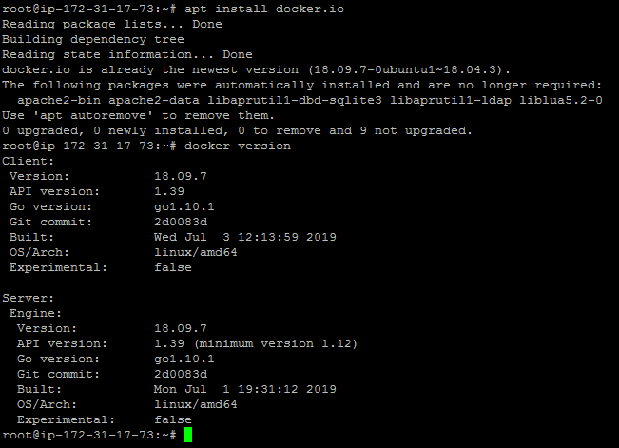

dockermanager

dockerworker1

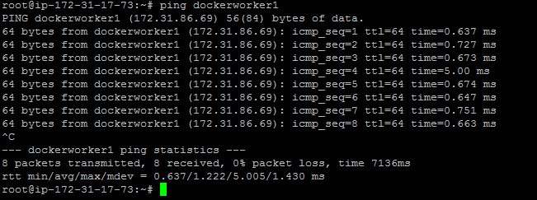

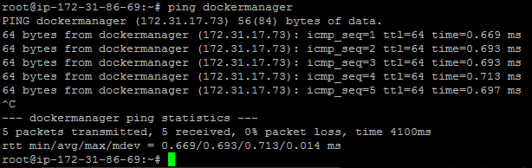

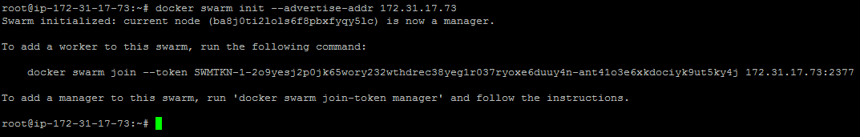

* Once the swarm cluster is initialized, allow the ports mentioned below in security groups





* cluster

docker node ls



